UNIT-V

Equipment Protection

**UNIT-V**

**POWER SYSTEM PROTECTION**

**Power System Protection**

The objective of **power system protection** is to isolate a faulty section of [electrical power](https://www.electrical4u.com/electric-power-single-and-three-phase/)system from rest of the live system so that the rest portion can function satisfactorily without any severer damage due to fault current.

Actually circuit breaker isolates the faulty system from rest of the healthy system and this circuit breakers automatically open during fault condition due to its trip signal comes from protection relay. The main philosophy about protection is that no protection of power system can prevent the flow of fault [current](https://www.electrical4u.com/electric-current-and-theory-of-electricity/) through the system, it only can prevent the continuation of flowing of fault current by quickly disconnect the short circuit path from the system. For satisfying this quick disconnection the protection relays should have following functional requirements.

**Protection System in Power System**

Let’s have a discussion on basic concept of **protection system in power system** and

coordination of protection relays.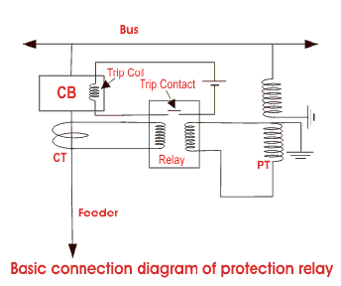

In the picture the basic connection of protection relay has been shown. It is quite simple. The secondary of current [transformer](https://www.electrical4u.com/what-is-transformer-definition-working-principle-of-transformer/) is connected to the current coil of relay. And secondary of [voltage transformer](https://www.electrical4u.com/voltage-transformer-or-potential-transformer-theory/) is connected to the voltage coil of the relay. Whenever any fault occurs in the feeder circuit, proportionate secondary current of the CT will flow through the current coil of the relay due to which mmf of that coil is increased. This increased mmf is sufficient to mechanically close the normally open contact of the relay. This relay contact actually closes and completes the DC trip coil circuit and hence the trip coil is energized. The mmf of the trip coil initiates the mechanical movement of the tripping mechanism of the circuit breaker and ultimately the circuit breaker is tripped to isolate the fault.

**Functional Requirements of Protection Relay**

**Reliability**

The most important requisite of protective relay is reliability. They remain inoperative for a long time before a fault occurs; but if a fault occurs, the relays must respond instantly and correctly.

**Selectivity**

The relay must be operated in only those conditions for which relays are commissioned in the [electrical power](https://www.electrical4u.com/electric-power-single-and-three-phase/) system. There may be some typical condition during fault for which some relays should not be operated or operated after some definite time delay hence protection relay must be sufficiently capable to select appropriate condition for which it would be operated.

**Sensitivity**

The relaying equipment must be sufficiently sensitive so that it can be operated reliably when level of fault condition just crosses the predefined limit.

**Speed**

The protective relays must operate at the required speed. There must be a correct coordination provided in various power system protection relays in such a way that for fault at one portion of the system should not disturb other healthy portion. Fault current may flow through a part of healthy portion since they are electrically connected but relays associated with that healthy portion should not be operated faster than the relays of faulty portion otherwise undesired interruption of healthy system may occur. Again if relay associated with faulty portion is not operated in proper time due to any defect in it or other reason, then only the next relay associated with the healthy portion of the system must be operated to isolate the fault. Hence it should neither be too slow which may result in damage to the equipment nor should it be too fast which may result in undesired operation.

**Important Elements for Power System Protection**

**Switchgear**

Consists of mainly [bulk oil circuit breaker](https://www.electrical4u.com/oil-circuit-breaker-bulk-and-minimum-oil-circuit-breaker/), [minimum oil circuit breaker](https://www.electrical4u.com/oil-circuit-breaker-bulk-and-minimum-oil-circuit-breaker/), [SF6 circuit breaker](https://www.electrical4u.com/types-and-operation-of-sf6-circuit-breaker/), [air blast circuit breaker](https://www.electrical4u.com/air-circuit-breaker-air-blast-circuit-breaker/) and [vacuum circuit breaker](https://www.electrical4u.com/vacuum-circuit-breaker-or-vcb-and-vacuum-interrupter/) etc. Different operating mechanisms such as solenoid, spring, pneumatic, hydraulic etc. are employed in the circuit breaker. Circuit breaker is the main part of protection system in power system and it automatically isolate the faulty portion of the system by opening its contacts.

**Protective Gear**

Consists of mainly power system protection relays like current relays, voltage relays, impedance relays, power relays, frequency relays, etc. based on operating parameter, definite time relays, inverse time relays, stepped relays etc. as per operating characteristic, logic wise such as differential relays, over fluxing relays etc. During fault the protection relay gives trip signal to the associated circuit breaker for opening its contacts.

**Station Battery**

All the circuit breakers of electrical power system are DC (Direct Current) operated. Because DC power can be stored in battery and if situation comes when total failure of incoming power occurs, still the circuit breakers can be operated for restoring the situation by the power of storage station [battery](https://www.electrical4u.com/battery-history-and-working-principle-of-batteries/). Hence, the battery is another essential item of the power system. Some time it is referred as the heart of the [electrical substation](https://www.electrical4u.com/electrical-power-substation-engineering-and-layout/). An electrical substation battery or simply a station battery containing a number of cells accumulate energy during the period of availability of AC supply and discharge at the time when relays operate so that relevant circuit breaker is tripped at the time failure of incoming AC power.

**Protection of Alternator**

# Differential Protection of Generator or Alternator

Any internal fault inside the stator winding is cleared by mainly **differential protection scheme of the generator** or alternator.  
The [differential protection](https://electrical4u.com/differential-protection-of-transformer-differential-relays/#Principle-of-Differential-Protection) is provided in the generator by using longitudinal [differential relay](https://electrical4u.com/differential-protection-of-transformer-differential-relays/#Principle-of-Differential-Protection).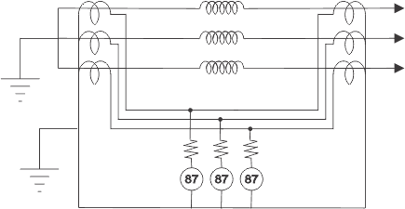

Generally [instantaneous attracted armature type relays](https://electrical4u.com/electromagnetic-relay-working-types-of-electromagnetic-relays/#Attraction-Armature-Type-Relay) are used for this purpose because all they have high speed operation and also they are free from being affected by any AC transient of the power circuit.

There are two sets of [current transformers](https://electrical4u.com/current-transformer-ct-class-ratio-error-phase-angle-error-in-current-transformer/) one [CT](https://www.electrical4u.com/current-transformer-ct-class-ratio-error-phase-angle-error-in-current-transformer/) is connected to the line side of the generator and other is connected to the neutral side of the generator in each phase. It is needless to say that the characteristics of all current transformers installed against each phase must be matched. If there is any major mismatched in the current transformer’s characteristics of both sides of the generator, there may be high chance of malfunctioning of differential relay during the fault external to the stator winding and also may be during normal operating conditions of the generator.

To ensure that the relay does not operate for the faults external to the operated zone of the protection scheme, a stabilizing [resistor](https://www.electrical4u.com/types-of-resistor-carbon-composition-and-wire-wound-resistor/) is fitted in series with the relay operating oil. It also ensures that if one set of CT has been saturated, there will be no possibility of malfunctioning of the differential relay.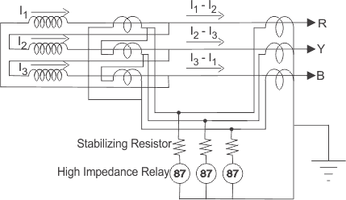

It is always preferable to use dedicated current transformers for differential protection purpose because common current transformers may cause unequal secondary loading for other functionalities imposed on them. It is also always preferable to use all current transformers for **differential protection of generators** or [alternators](https://electrical4u.com/alternator-or-synchronous-generator/) should be of same characteristics. But practically there may be some difference in characteristics of the current transformers installed at line side to those installed in neutral side of the generator. These mismatches cause spill current to flow through the relay operating coil. To avoid the effect of spill current, percentage biasing is introduced in differential relay.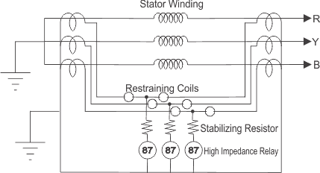

The percentage biased differential relay comprises two restraint coils and one operating coil per phase. In the relay, the torque produced by operating coil tends to close the relay contacts for instantaneous tripping of [circuit breakers](https://www.electrical4u.com/electrical-circuit-breaker-operation-and-types-of-circuit-breaker/) but at the same time the torque produced by the restraint coils prevents to close the relay contacts as restraint coils torque is directed opposite of the operating coil torque. Hence during through fault the differential relay would not be operated because the setting of the relay is increased by restraint coils and also it prevents malfunctioning of relay due to spill current. But during internal fault in the winding of the stator, the torque produced by restraint coils is ineffective and the relay closes its contact when setting current flows through the operating coil.

Differential current pickup setting/bias setting of the relay is adopted based on the maximum percentage of allowable mismatch adding some safety margin.  
The spill current level for the relay is to just operate it; is experienced as a percentage of the through fault current causing it. This percentage is defined as bias setting of the relay.

# Rotor Earth Fault Protection of Alternator or Generator

The rotor of an [alternator](https://www.electrical4u.com/alternator-or-synchronous-generator/) is wound by field winding. Any single earth fault occurring on the field winding or in the exciter circuit is not a big problem for the machine. But if more than one earth fault occur, there may be a chance of short circuiting between the faulty points on the winding. This short circuited portion of the winding may cause unbalance [magnetic field](https://www.electrical4u.com/what-is-magnetic-field/)and subsequently mechanical damage may occur in the bearing of the machine due to unbalanced rotation. Hence it is always essential to detect the earth fault occurred on the rotor field winding circuit and to rectify it for normal operation of the machine. There are various methods available for detecting rotor earth fault of alternator or generator. But basic principle of all the methods is same and that is closing a relay circuit through the earth fault path. There are mainly three types of **rotor earth fault protection** scheme used for this purpose.

1. Potentiometer method
2. AC injection method
3. DC injection method

Let us discuss the methods one by one.

**Potentiometer Method of Rotor Earth Fault Protection in Alternator**

The scheme is very simple. Here, one [resistor](https://www.electrical4u.com/types-of-resistor-carbon-composition-and-wire-wound-resistor/) of suitable value is connected across the field winding as well as across exciter. The resistor is centrally tapped and connected to the ground via a voltage sensitive relay. As it is seen in the figure below, any earth fault in the field winding as well as exciter circuit closes the relay circuit through earthed path. At the same time the [voltage](https://www.electrical4u.com/voltage-or-electric-potential-difference/) appears across the relay due to [potentiometer](https://www.electrical4u.com/potentiometer-working-principle-of-potentiometer/) action of the resistor.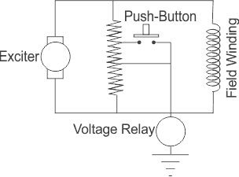

This simple method of **rotor earth fault protection of alternator** has a big disadvantage. This arrangement can only sense the earth fault occurred in the any point except the center of the field winding. From the circuit it is also clear that in the case of earth fault on the center of the field circuit will not cause any voltage to be appeared across the relay. That means simple potentiometer methods of **rotor earth fault protection**, is blind to the faults at the center of the field winding. This difficulty can be minimized by using another tap on the resistor somewhere else from the center of the resistor via a push button. If this push button is pressed, the center tap is shift and the voltage will appear across the relay even in the event of central arc fault occurs on the field winding.

**AC Injection Method of Rotor Earth Fault Protection in Alternator**

Here, one voltage sensitive relay is connected at any point of the field and exciter circuit. Other terminal of the voltage sensitive relay is connected to the ground by a [capacitor](https://www.electrical4u.com/what-is-capacitor-and-what-is-dielectric/) and secondary of one auxiliary [transformer](https://www.electrical4u.com/what-is-transformer-definition-working-principle-of-transformer/) as shown in the figure below.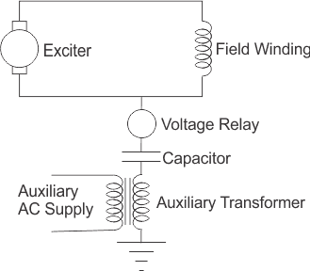

Here, if any earth fault occurs in the field winding or in the exciter circuit, the relay circuit gets closed via earthed path and hence secondary voltage of the auxiliary transformer will appear across the voltage sensitive relay and the relay will be operated. The main disadvantage of this system is, there would always be a chance of leakage [current](https://www.electrical4u.com/electric-current-and-theory-of-electricity/) through the capacitors to the exciter and field circuit. This may cause unbalancing in magnetic field and hence mechanical stresses in the machine bearings.

Another disadvantage of this scheme is that as there is different source of voltage for operation of the relay, thus the protection of rotor is inactive when there is a failure of supply in the AC circuit of the scheme.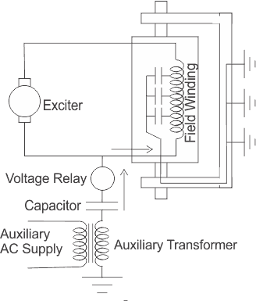

**DC Injection Method of Rotor Earth Fault Protection in Alternator**

The drawback of leakage current of AC injection method can be eliminated in DC Injection Method. Here, one terminal of DC voltage sensitive relay is connected with positive terminal of the exciter and another terminal of the relay is connected with the negative terminal of an external DC source. The external DC source is obtained by an auxiliary transformer with bridge rectifier. Here the positive terminal of bridge rectifier is grounded.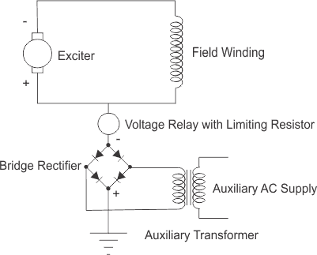

It is also seen from the figure below that at the event of any field earth fault or exciter earth fault, the positive potential of the external DC source will appear to the terminal of the relay which was connected to the positive terminal of the exciter. In this way the rectifier output voltage appears across the voltage relay and hence it is operated.

# Loss of Field or Excitation Protection of Alternator or Generator

**Loss of field** or excitation can be caused in the generator due to excitation failure. In larger sized generator, energy for excitation is often taken from a separate auxiliary source or from a separately driven [DC generator](https://www.electrical4u.com/principle-of-dc-generator/). The failure of auxiliary supply or failure of driving motor can also cause the **loss of excitation** in a generator. Failure of excitation that is failure of field system in the generator makes the generator run at a speed above the synchronous speed.  
In that situation the generator or [alternator](https://www.electrical4u.com/alternator-or-synchronous-generator/) becomes an [induction generator](https://www.electrical4u.com/induction-generator/) which draws magnetizing current from the system. Although this situation does not create any problem in the system immediately but over loading of the stator and overheating of the rotor due to continuous operation of the machine in this mode may create problems in the system in long-run. Therefore special care should be taken for rectifying the field or excitation system of the generator immediately after failure of that system. The generator should be isolated from rest of the system till the field system is properly restored.

There are mainly two schemes available for protection against loss of field or excitation of a generator. In 1st scheme, we use an undercurrent relay connected in shunt with main field winding circuit. This relay will operate if the excitation current comes below its predetermined value. If the relay is to operate for complete loss of field along, it must have a setting lies well below the minimum excitation current value which can be 8 % of the rated full load [current](https://www.electrical4u.com/electric-current-and-theory-of-electricity/). Again when loss of field occurs due to failure of exciter but not due to problem in the field circuit (field circuit remains intact) there will be an induced current at slip frequency in the field circuit. This situation makes the relay to pick up and drop off as per slip frequency of the induced current in the field. This problem can be overcome in the following manner.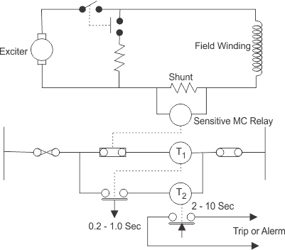

In this case a setting of 5 % of normal of full load current is recommended. There is a normally closed contact attached with the undercurrent relay. This normally closed contact remains open as the relay coil is energized by shunted excitation current during normal operation of the excitation system. As soon as there is any failure of excitation system, the relay coil becomes de-energized and the normally closed contact closes the supply across the coil of timing relay T1.

As the relay coil is energized, the normally open contact of this relay T 1 is closed. This contact closes the supply across another timing relay T 2with an adjustable pickup time delay of 2 to 10 seconds. Relay T 1 is time delayed on drop off to stabilize scheme again slip frequency effect. Relay T 2closes its contacts after the prescribed time delay to either shut down the set or initiate an alarm. It is time delayed on pickup to prevent spurious operation of the scheme during an external fault.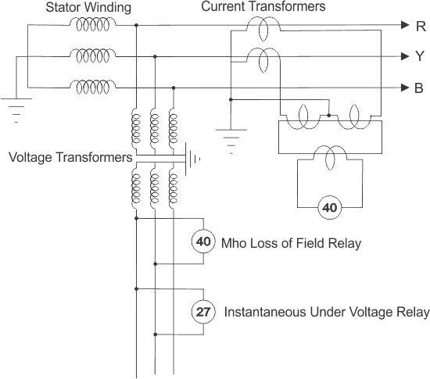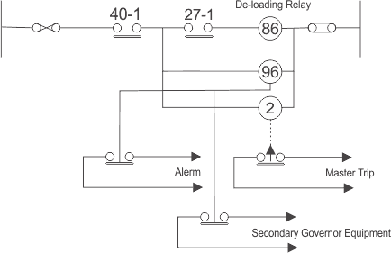

For larger generator or alternator, we use a more sophisticated scheme for that purpose. For larger machines, it is recommended to trip the machine after a certain prescribed delay in presence of swing condition resulting from loss of field. In addition to that there must be subsequent load shedding to maintain stability of the system. In this scheme of protection, an automatic imposition of load shedding to the system is also inherently required if the field is not restored within the described time delay. The scheme comprises an offset mho relay, and an instantaneous under voltage relay. As we have said earlier that it is not always required to isolate the generator immediately in the event of loss of field, unless there is a significant disturb in system stability.

We know that system voltage is the main indication of system stability. Therefore the offset mho relay is arranged to shut the machine down instantaneously when operation of generator is accompanied by a system voltage collapse. The drop in system voltage is detected by an under [voltage](https://www.electrical4u.com/voltage-or-electric-potential-difference/) relay which is set to approximately 70 % of normal rated system voltage. The offset mho relay is arranged to initiate load shedding to the system up to a safe value and then to initiate a master tripping relay after a predetermined time.

# Stator Earth Fault Protection of Alternator

This is to be noted that, the star point or neutral point of stator winding of an [alternator](https://www.electrical4u.com/alternator-or-synchronous-generator/) is grounded through an impedance to limit the ground fault current. Reduced ground fault current causes less damage to the stator core and winding during ground or earth fault. If the ground impedance is made quite high, the ground fault current may become even less than normal rated current of the generator. If so, the sensitivity of phase relays becomes low, even they may fail to trip during fault. For example, a current lower than rated current makes it difficult to operate [differential relays](https://www.electrical4u.com/differential-relay/) for ground fault. In that case, a sensitive ground/earth fault relay is used in addition to the [differential protection of alternator](https://www.electrical4u.com/differential-protection-of-generator-or-alternator/). What type of relaying arrangement will be engaged in **stator earth fault protection of alternator** depends upon the methods of stator neutral earthing. In the case of [resistance](https://www.electrical4u.com/electrical-resistance-and-laws-of-resistance/" \o "Know about Resistance in detail.)neutral earthing the neutral point of stator winding is connected to the ground through a [resistor](https://www.electrical4u.com/types-of-resistor-carbon-composition-and-wire-wound-resistor/).

Here, one [current transformer](https://www.electrical4u.com/current-transformer-ct-class-ratio-error-phase-angle-error-in-current-transformer/) is connected across the neutral and earth connection of the alternator. Now one [protective relay](https://www.electrical4u.com/types-of-electrical-protection-relays-or-protective-relays/) is connected across the current transformer secondary. The alternator can feed the power system in two ways, either it is directly connected to the [substation](https://www.electrical4u.com/electrical-power-substation-engineering-and-layout/) bus bar or it is connected to substation via one [star delta transformer](https://www.electrical4u.com/delta-star-transformation-star-delta-transformation/). If the generator is connected directly to the substation bus bars, the relay connected across the CT secondary, would be an inverse time relay because here, relay coordination is required with other fault relays in the system. But when the stator of the alternator is connected to the primary of a star Delta transformer, the fault is restricted in between stator winding and transformer primary winding, therefore no coordination or discrimination is required with other earth fault relays of the system. That is why; in this case instantaneous armature attracted type relay is preferable to be connected across the CT secondary.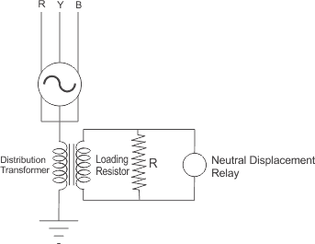

It is should be noted that, 100 % of the stator winding cannot be protected in resistance neutral earthing system. How much percentage of stator winding would be protected against earth fault, depends upon the value of earthing resistance and the setting of relay.  
The resistance grounding of stator winding can also be made by using a distribution transformer instead of connecting a resistor directly to the neutral path of the winding. Here, primary of a [distribution transformer](https://www.electrical4u.com/distribution-transformer-efficiency-of-distribution-transformer-all-day-efficiency/) is connected across earth and neutral point of the stator winding.  
Secondary of the transformer is loaded by a suitable resistor and one over voltage relay is also connected across the secondary of the transformer. The maximum allowable earth fault current is determined by the size of the [transformer](https://www.electrical4u.com/what-is-transformer-definition-working-principle-of-transformer/) and the value of loading register R. This resistance is connected with the secondary, reflects to the primary of the transformer by the square of the [turns ratio](https://www.electrical4u.com/emf-equation-of-transformer-turns-voltage-transformation-ratio-of-transformer/), thereby adding resistance to the neutral to ground path of the stator winding.

# Inter Turn Fault Protection of Stator Windin

Inter turn stator winding fault can easily be detected by stator differential protection or [stator earth fault protection](https://www.electrical4u.com/stator-earth-fault-protection-of-alternator/). Hence, it is not very essential to provide special protection scheme for inter turn faults occurred in stator winding. This type of faults is generated if the insulation between [conductors](https://www.electrical4u.com/electrical-conductor/) (with [different potential](https://www.electrical4u.com/voltage-or-electric-potential-difference/)) in the same slot is punctured. This type of fault rapidly changes to earth fault.  
The high [voltage](https://www.electrical4u.com/voltage-or-electric-potential-difference/) generator contains a large number of conductors per slot in the stator winding hence, in these cases the additional inter turn fault protection of the stator winding may be essential. Moreover in modern practice, inter turn protection is becoming essential for all large generating units.

Several methods can be adopted for providing **inter turn protection to the stator winding of generator**. Cross differential methods is most common among them. In this scheme the winding for each phase is divided into two parallel paths.  
Each of the paths is fitted with identical [current transformer](https://www.electrical4u.com/current-transformer-ct-class-ratio-error-phase-angle-error-in-current-transformer/). The secondary of these current transformers are connected in cross. The current transformer secondary's are cross connected because [currents](https://www.electrical4u.com/electric-current-and-theory-of-electricity/) at the primary of both CTs are entering unlike the case of [differential protection of transformer](https://www.electrical4u.com/differential-protection-of-transformer-differential-relays/) where current entering from one side and leaving to other side of the [transformer](https://www.electrical4u.com/what-is-transformer-definition-working-principle-of-transformer/). The [differential relay](https://electrical4u.com/differential-relay/) along with series stabilizing resistor are connected across the CT secondary loop as shown in the figure. If any inter turn fault occurs in any path of the stator winding, there will be an unbalanced in the CT secondary circuits thereby actuates 87 differential relay. Cross differential protection scheme should be applied in each of the phases individually as shown.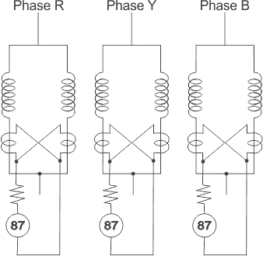

An alternative scheme of **inter turn fault protection of stator winding of generator** is also used. This scheme provides complete protection against internal faults of all synchronous machines irrespective of the type of the winding employed or the kind of methods for connection. An internal fault in the stator winding generates second harmonic current, included in the field winding and exciter circuits of the generator. This current can be applied to a sensitive polarized relay via a CT and filter circuit.

The scheme operation is controlled by a direction of negative phase sequence relay, in order to prevent operation during external unbalanced faults or asymmetrical load conditions. Should there be any asymmetry external to the generator unit zone, the negative phase sequence relay prevents a complete shutdown, only allowing the main [circuit breaker](https://www.electrical4u.com/electrical-circuit-breaker-operation-and-types-of-circuit-breaker/) to be tripped, to prevent the rotor damage due to the over rating effects of second harmonic currents.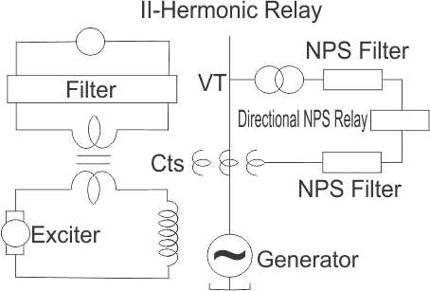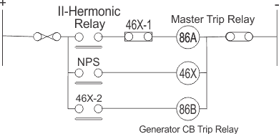

**Transformer Protection**

# External and Internal Faults in Transformer

It is essential to protect high capacity [transformers](https://www.electrical4u.com/what-is-transformer-definition-working-principle-of-transformer/) against **external and internal electrical faults**.

**External Faults in Power Transformer**

**External Short Circuit of Power Transformer**

The short - circuit may occur in two or three phases of [electrical power](https://www.electrical4u.com/electric-power-single-and-three-phase/) system. The level of fault [current](https://www.electrical4u.com/electric-current-and-theory-of-electricity/) is always high enough. It depends upon the [voltage](https://www.electrical4u.com/voltage-or-electric-potential-difference/) which has been short-circuited and upon the impedance of the circuit up to the fault point. The copper loss of the fault feeding transformer is abruptly increased. This increasing copper loss causes internal heating in the transformer. Large fault current also produces severe mechanical stresses in the transformer. The maximum mechanical stresses occur during first cycle of symmetrical fault current.

### High Voltage Disturbance in Power Transformer

**High voltage disturbance in power transformer** are of two kinds,

1. Transient Surge Voltage
2. Power Frequency Over Voltage

#### Transient Surge Voltage

High voltage and high frequency surge may arise in the power system due to any of the following causes,

* Arcing ground if neutral point is isolated.
* Switching operation of different electrical equipment.
* Atmospheric Lightening Impulse.

Whatever may be the causes of surge voltage, it is after all a traveling wave having high and steep wave form and also having high frequency. This wave travels in the electrical power system network, upon reaching in the [power transformer](https://www.electrical4u.com/electrical-power-transformer-definition-and-types-of-transformer/), it causes breakdown of the insulation between turns adjacent to line terminal, which may create short circuit between turns.

#### Power Frequency Over Voltage

There may be always a chance of system over voltage due to sudden disconnection of large load. Although the amplitude of this voltage is higher than its normal level but frequency is same as it was in normal condition. Over voltage in the system causes an increase in stress on the insulation of transformer. As we know that, voltage https://www.electrical4u.com/images/2017/may/1493617032.PNG, increased voltage causes proportionate increase in the working flux. This therefore causes, increased in iron loss and proportionately large increase in magnetizing current. The increase flux is diverted from the transformer core to other steel structural parts of the transformer. Core bolts which normally carry little flux, may be subjected to a large component of [flux](https://www.electrical4u.com/what-is-flux-types-of-flux/) diverted from saturated region of the core alongside. Under such condition, the bolt may be rapidly heated up and destroys their own insulation as well as winding insulation.

#### Under Frequency Effect in Power Transformer

As, voltage https://www.electrical4u.com/images/2017/may/1493617110.PNG as the number of turns in the winding is fixed.  
Therefore,https://www.electrical4u.com/images/2017/may/1493617230.PNGFrom, this equation it is clear that if frequency reduces in a system, the flux in the core increases, the effect are more or less similar to that of the over voltage.

## Internal Faults in Power Transformer

The principle faults which occurs inside a power transformer are categorized as,

1. Insulation breakdown between winding and earth
2. Insulation breakdown in between different phases
3. Insulation breakdown in between adjacent turns i.e. inter - turn fault
4. Transformer core fault

### Internal Earth Faults in Power Transformer

#### Internal Earth Faults in a Star Connected Winding with Neutral Point Earthed through an Impedance

In this case the fault current is dependent on the value of earthing impedance and is also proportional to the distance of the fault point from neutral point as the voltage at the point depends upon, the number of winding turns come across neutral and fault point. If the distance between fault point and neutral point is more, the number of turns under this distance is also more, hence voltage across the neutral point and fault point is high which causes higher fault current. So, in few words it can be said that, the value of fault current depends on the value of earthing impedance as well as the distance between the faulty point and neutral point. The fault current also depends up on [leakage reactance](https://www.electrical4u.com/resistance-leakage-reactance-or-impedance-of-transformer/#Leakage-Reactance-of-Transformer) of the portion of the winding across the fault point and neutral. But compared to the earthing impedance,it is very low and it is obviously ignored as it comes in series with comparatively much higher earthing impedance.

#### Internal Earth Faults in a Star Connected Winding with Neutral Point Solidly Earthed

In this case, earthing impedance is ideally zero. The fault current is dependent up on leakage reactance of the portion of winding comes across faulty point and neutral point of transformer. The fault current is also dependent on the distance between neutral point and fault point in the transformer. As said in previous case the voltage across these two points depends upon the number of winding turn comes across faulty point and neutral point. So in star connected winding with neutral point solidly earthed, the fault current depends upon two main factors, first the leakage reactance of the winding comes across faulty point and neutral point and secondly the distance between faulty point and neutral point. But the leakage reactance of the winding varies in complex manner with position of the fault in the winding. It is seen that the reactance decreases very rapidly for fault point approaching the neutral and hence the fault current is highest for the fault near the neutral end. So at this point, the voltage available for fault current is low and at the same time the reactance opposes the fault current is also low, hence the value of fault current is high enough. Again at fault point away from the neutral point, the voltage available for fault current is high but at the same time reactance offered by the winding portion between fault point and neutral point is high. It can be noticed that the fault current stays a very high level throughout the winding. In other word, the fault current maintain a very high magnitude irrelevant to the position of the fault on winding.

### Internal Phase to Phase Faults in Power Transformer

Phase to phase fault in the transformer are rare. If such a fault does occur, it will give rise to substantial current to operate instantaneous [over current relay](https://www.electrical4u.com/over-current-relay-working-principle-types/) on the primary side as well as the [differential relay](https://www.electrical4u.com/differential-relay/).

### Inter Turns Fault in Power Transformer

Power Transformer connected with electrical extra high voltage transmission system, is very likely to be subjected to high magnitude, steep fronted and high frequency impulse voltage due to lightening surge on the transmission line. The voltage stresses between winding turns become so large, it can not sustain the stress and causing insulation failure between inter - turns in some points. Also LV winding is stressed because of the transferred surge voltage. Very large number of Power Transformer failure arises from fault between turns. Inter turn fault may also be occurred due to mechanical forces between turns originated by external short circuit.

## Core Fault in Power Transformer

In any portion of the core lamination is damaged, or lamination of the core is bridged by any conducting material that causes sufficient [eddy current](https://www.electrical4u.com/hysteresis-eddy-current-iron-or-core-losses-and-copper-loss-in-transformer/) to flow, hence, this part of the core becomes over heated. Sometimes, insulation of bolts (Used for tightening the core lamination together) fails which also permits sufficient eddy current to flow through the bolt and causing over heating. This insulation failure in lamination and core bolts causes severe local heating. Although these local heating, causes additional core loss but can not create any noticeable change in input and output current in the transformer, hence these faults cannot be detected by normal [electrical protection](https://www.electrical4u.com/protection-system-in-power-system/) scheme. This is desirable to detect the local over heating condition of the transformer core before any major fault occurs. Excessive over heating leads to breakdown of transformer insulating oil with evolution of gases. These gases are accumulated in [Buchholz relay](https://www.electrical4u.com/buchholz-relay-in-transformer-buchholz-relay-operation-and-principle/) and actuating Buchholz Alarm.

# Backup Protection of Transformer | Over Current and Earth Fault

**Over Current and Earth Fault Protection of Transformer**

**Backup protection of electrical transformer** is simple **Over Current and Earth Fault protection** are applied against external short circuit and excessive over loads. These over current and earth Fault relays may be of Inverse Definite Minimum Time (**IDMT**) or Definite Time type relays (DMT). Generally IDMT relays are connected to the in-feed side of the transformer.  
The over current relays can not distinguish between external short circuit, over load and internal faults of the [transformer](https://www.electrical4u.com/what-is-transformer-definition-working-principle-of-transformer/). For any of the above fault, **backup protection** i.e. **over current and earth fault protection** connected to in-feed side of the transformer will operate.

Backup protection is although generally installed at in feed side of the transformer, but it should trip both the primary and secondary [circuit breakers](https://www.electrical4u.com/electrical-circuit-breaker-operation-and-types-of-circuit-breaker/) of the transformer.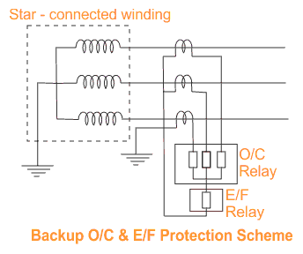

Over Current and Earth Fault [protection relays](https://www.electrical4u.com/types-of-electrical-protection-relays-or-protective-relays/) may be also provided in load side of the transformer too, but it should not inter trip the primary side circuit breaker like the case of backup protection at in-feed side. The operation is governed primarily by [current](https://www.electrical4u.com/electric-current-and-theory-of-electricity/) and time settings and the characteristic curve of the relay. To permit use of over load capacity of the transformer and co-ordination with other similar relays at about 125 to 150% of full load current of the transformer but below the minimum short circuit current.

**Backup**[**protection of transformer**](https://www.electrical4u.com/transformer-protection-and-transformer-fault/) has four elements; three over current relays connected each in each phase and one earth fault relay connected to the common point of three over current relays as shown in the figure. The normal range of current settings available on IDMT over current relays are 50% to 200% and on earth fault relay 20 to 80%.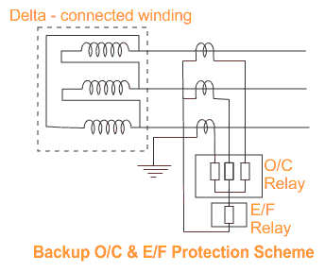

Another range of setting on earth fault relay is also available and may be selected where the earth fault current is restricted due to insertion of impedance in the neutral grounding. In the case of transformer winding with neutral earthed, unrestricted earth fault protection is obtained by connecting an ordinary earth fault relay across a neutral [current transformer](https://www.electrical4u.com/current-transformer-ct-class-ratio-error-phase-angle-error-in-current-transformer/).  
The unrestricted over current and earth fault relays should have proper time lag to co-ordinate with the protective relays of other circuit to avoid indiscriminate tripping.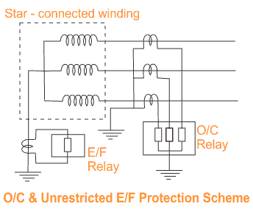

# Busbar Protection

# Busbar Differential Protection Scheme

In early days only conventional over [current](https://www.electrical4u.com/electric-current-and-theory-of-electricity/) relays were used for **busbar protection**. But it is desired that fault in any feeder or [transformer](https://www.electrical4u.com/electrical-power-transformer-definition-and-types-of-transformer/) connected to the busbar should not disturb busbar system. In viewing of this time setting of busbar protection relays are made lengthy. So when faults occurs on busbar itself, it takes much time to isolate the bus from source which may came much damage in the [bus system](https://www.electrical4u.com/electrical-bus-system-and-electrical-substation-layout/).  
In recent days, the second zone distance protection relays on incoming feeder, with operating time of 0.3 to 0.5 seconds have been applied for **busbar protection**.  
But this scheme has also a main disadvantage. This scheme of protection can not discriminate the faulty section of the busbar.

Now days, [electrical power](https://www.electrical4u.com/electric-power-single-and-three-phase/) system deals with huge amount of power. Hence any interruption in total bus system causes big loss to the company. So it becomes essential to isolate only faulty section of busbar during bus fault. Another drawback of second zone distance protection scheme is that, sometime the clearing time is not short enough to ensure the system stability.  
To overcome the above mentioned difficulties, differential busbar protection scheme with an operating time less than 0.1 sec., is commonly applied to many SHT bus systems.

**Differential Busbar Protection**

**Current Differential Protection**

The scheme of **busbar protection**, involves, [Kirchoff’s current law](https://www.electrical4u.com/kirchhoff-current-law-and-kirchhoff-voltage-law/), which states that, total current entering an electrical node is exactly equal to total current leaving the node.  
Hence, total current entering into a bus section is equal to total current leaving the bus section.  
The principle of differential busbar protection is very simple. Here, secondaries of [CTs](https://www.electrical4u.com/current-transformer-ct-class-ratio-error-phase-angle-error-in-current-transformer/) are connected parallel. That means, S1 terminals of all CTs connected together and forms a bus wire. Similarly S2 terminals of all CTs connected together to form another bus wire.  
A tripping relay is connected across these two bus wires.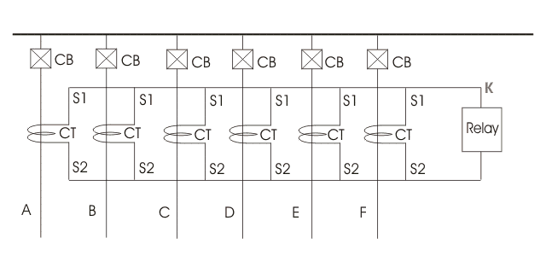Here, in the figure above we assume that at normal condition feed, A, B, C, D, E and F carries current IA, IB, IC, ID, IE and IF.  
Now, according to Kirchoff’s current law,https://www.electrical4u.com/equations/bp-06-06-14-1.gifEssentially all the CTs used for differential busbar protection are of same current ratio. Hence, the summation of all secondary currents must also be equal to zero. Now, say current through the relay connected in parallel with all CT secondaries, is iR, and iA, iB, iC, iD, iE and iF are secondary currents.  
Now, let us apply [KCL](https://www.electrical4u.com/kirchhoff-current-law-and-kirchhoff-voltage-law/) at node X. As per KCL at node X,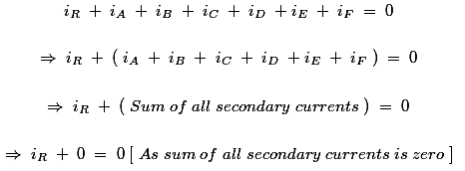So, it is clear that under normal condition there is no current flows through the **busbar protection** tripping relay. This [relay](https://www.electrical4u.com/types-of-electrical-protection-relays-or-protective-relays/) is generally referred as Relay 87. Now, say fault is occurred at any of the feeders, outside the protected zone. In that case, the faulty current will pass through primary of the CT of that feeder. This fault current is contributed by all other feeders connected to the bus. So, contributed part of fault current flows through the corresponding CT of respective feeder. Hence at that faulty condition, if we apply KCL at node K, we will still get, iR = 0.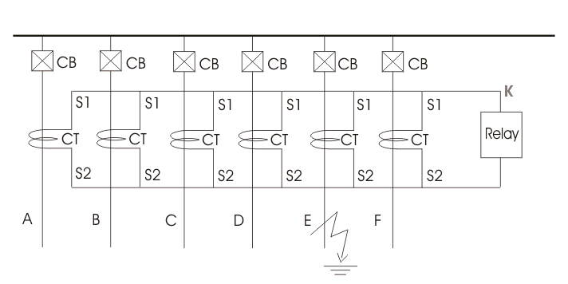That means, at external faulty condition, there is no current flows through relay 87. Now consider a situation when fault is occurred on the bus itself.  
At this condition, also the faulty current is contributed by all feeders connected to the bus. Hence, at this condition, sum of all contributed fault current is equal to total faulty current.  
Now, at faulty path there is no CT. (in external fault, both fault current and contributed current to the fault by different feeder get CT in their path of flowing).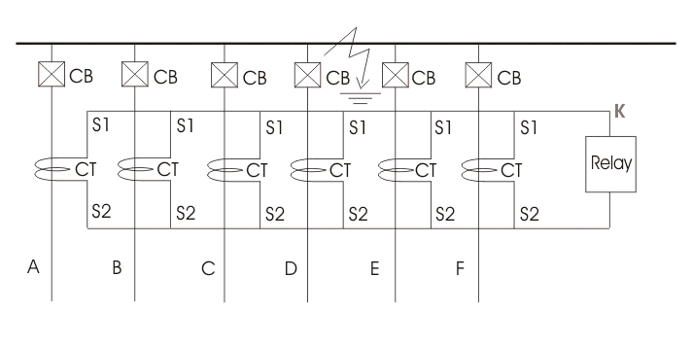The sum of all secondary currents is no longer zero. It is equal to secondary equivalent of faulty current.  
Now, if we apply KCL at the nodes, we will get a non zero value of iR.  
So at this condition current starts flowing through 87 relay and it makes trip the [circuit breaker](https://www.electrical4u.com/electrical-circuit-breaker-operation-and-types-of-circuit-breaker/) corresponding to all the feeders connected to this section of the busbar.  
As all the incoming and outgoing feeders, connected to this section of bus are tripped, the bus becomes dead.  
This differential busbar protection scheme is also referred as current differential protection of busbar.

**Differential Protection of Sectionalized Bus**

During explaining working principle of current differential protection of busbar, we have shown a simple non sectionalized busbar. But in moderate high [voltage](https://www.electrical4u.com/voltage-or-electric-potential-difference/) system electrical bus sectionalized in than one sections to increase stability of the system. It is done because, fault in one section of bus should not disturb other section of the system. Hence during bus fault, total bus would be interrupted.  
Let us draw and discuss about protection of busbar with two sections.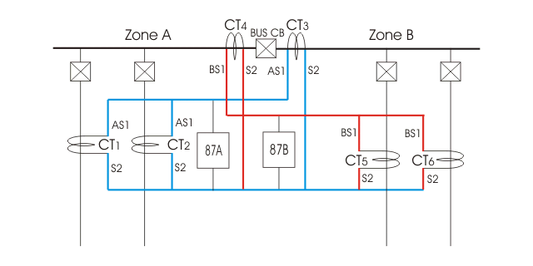Here, bus section A or zone A is bounded by CT1, CT2 and CT3 where CT1 and CT2 are feeder CTs and CT3 is bus CT.  
Similarly bus section B or zone B is bounded by CT4, CT5 and CT6 where CT4 is bus CT, CT5and CT6 are feeder CT.  
Therefore, zone A and B are overlapped to ensure that, there is no zone left behind this **busbar protection** scheme.  
ASI terminals of CT1, 2 and 3 are connected together to form secondary bus ASI;  
BSI terminals of CT4, 5 and 6 are connected together to form secondary bus BSI.  
S2 terminals of all CTs are connected together to form a common bus S2.  
Now, busbar protection relay 87A for zone A is connected across bus ASI and S2.  
Relay 87B for zone B is connected across bus BSI and S2.  
This section **busbar differential protection scheme** operates in some manner simple current differential protection of busbar.  
That is, any fault in zone A, with trip only CB1, CB2 and bus CB.  
Any fault in zone B, will trip only CB5, CB6 and bus [CB](https://www.electrical4u.com/electrical-circuit-breaker-operation-and-types-of-circuit-breaker/).  
Hence, fault in any section of bus will isolate only that portion from live system.  
In current differential protection of busbar, if CT secondary circuits, or bus wires is open the relay may be operated to isolate the bus from live system. But this is not desirable.

**DC Circuit of Differential Busbar Protection**

A typical [DC circuit](https://www.electrical4u.com/electrical-dc-series-and-parallel-circuit/) for **busbar differential protection scheme** is given below.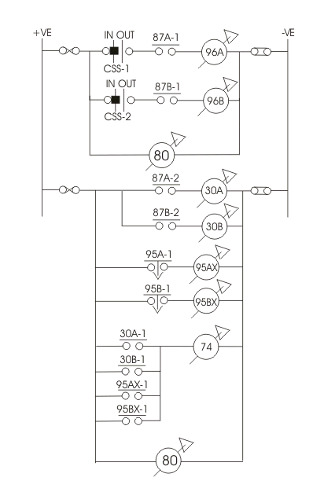

Here, CSSA and CSSB are two selector switch which are used to put into service, the **busbar protection** system for zone A and zone B respectively.  
If CSSA is in “IN” position, protection scheme for zone A is in service.  
If CSSB is in “IN” position, protection for zone B is in service.  
Generally both of the switches are in “IN’ position in normal operating condition. Here, relay coil of 96A and 96B are in series with differential busbar protection relay contact 87A-1 and 87B-1 respectively.  
96A relay is multi contacts relay. Each circuit breaker in zone A is connected with individual contact of 96A.  
Similarly, 96B is multi contacts relay and each circuit breaker in zone-B is connected with individual contacts of 96B.  
Although here we use only one tripping relay per protected zone, but this is better to use one individual tripping relay per feeder. In this scheme one [protective relay](https://www.electrical4u.com/types-of-electrical-protection-relays-or-protective-relays/) is provided per feeder circuit breaker, whereas two tripping relays one for zone A and other for zone B are provided to bus section or bus coupler circuit breaker.  
On an interval fault in zone A or bus section A, the respective bus protection relay 87A, be energized whereas during internal fault in zone B, the respective relay 87B will be energized.  
As soon as relay coil of 87A or 87B is energized respective no. contact 87A-1 or 87B-1 is closed.Hence, the tripping relay 96 will trip the breakers connected to the faulty zone. To indicate whether zone A or B busbar protection operated, relay 30 is used.  
For example, if relay 87A is operated, corresponding “No” contact 87A-2 is closed which energized relay 30A. Then the No contact 30A-1 of relay 30A is closed to energized alarm relay 74. Supervision relay 95 of respective zone is also energized during internal fault, but it has a time delay of 3 second. So, it reset as soon as the fault is cleared and therefore does not pick up zone bus wire shorting relay 95x which in turn shorts out the bus wires. An alarm contact is also given to this auxiliary 95x relay to indicate which CT is open circuited. No volt relay 80 is provided in both trip and non-trip section of the DC circuit of differential busbar protection system to indicate any discontinuity of D. C. supply.

**Voltage Differential Protection of Busbar**

The current differential scheme is sensitive only when the CTs do not get saturated and maintain same current ratio, phase angle error under maximum faulty condition. This is usually not 80, particularly, in the case of an external fault on one of the feeders. The CT on the faulty feeder may be saturated by total current and consequently it will have very large errors. Due to this large error, the summation of secondary current of all CTs in a particular zone may not be zero. So there may be a high chance of tripping of all circuit breakers associated with this protection zone even in the case of an external large fault. To prevent this maloperation of current differential **busbar protection**, the 87 relays are provided with high pick up current and enough time delay.  
The greatest troublesome cause of [current transformer](https://www.electrical4u.com/current-transformer-ct-class-ratio-error-phase-angle-error-in-current-transformer/) saturation is the transient dc component of the short circuit current.  
This difficulties can be overcome by using air core CTs. This current transformer is also called linear coupler. As the core of the CT does not use iron the secondary characteristic of these CTs, is straight line.  
In voltage differential busbar protection the CTs of all incoming and outgoing feeders are connected in series instead of connecting them in parallel.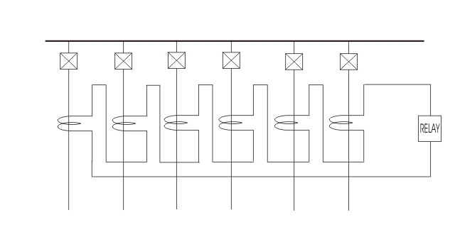The secondaries of all CTs and [differential relay](https://www.electrical4u.com/differential-relay/) form a closed loop. If polarity of all CTs are properly matched, the sum of voltage across all CT secondaries is zero. Hence there would be no resultant voltage appears across the differential relay. When a buss fault occurs, sum of the all CT secondary voltage is no longer zero. Hence, there would be current circulate in the loop due to the resultant voltage. As this loop current also flows through the differential relay, the relay is operated to trip all the circuit beaker associated with protected bus zone. Except when ground fault current is severally limited by neutral impedance there is usually no selectivity problem when such a problem exists, it is solved by use of an additional more sensitive relaying equipment including a supervising protective relay.

5.Feeder Protection:

The probability of faults occurring on the lines is much more due to their greater length and exposure to atmospheric conditions. This has called for many protective schemes which have no application to the comparatively simple cases of alternators and transformers. The requirements of line protection are :

**(*i*)** In the event of a short-circuit, the circuit breaker closest to the fault should open, all other circuit breakers remaining in a closed position.

**(*ii*)** In case the nearest breaker to the fault fails to open, back-up protection should be provided by the adjacent circuit breakers.

**(*iii*)** The relay operating time should be just as short as possible in order to preserve system stability, without unnecessary tripping of circuits.

The protection of lines presents a problem quite different from the protection of station apparatus such as generators, transformers and busbars. While differential protection is ideal method for lines, it is much more expensive to use. The two ends of a line may be several kilometres apart and to compare the two currents, a costly pilot-wire circuit is required. This expense may be justified but in general less costly methods are used. The common methods of line protection are :

**(*i*)** Time-graded overcurrent protection

**(*ii*)** Differential protection

**(*iii*)** Distance protection

5.1. Time-Graded Overcurrent Protection

In this scheme of overcurrent protection, time discrimination is incorporated. In other words, the time setting of relays is so graded that in the event of fault, the smallest possible part of the system is isolated. We shall discuss a few important cases.

**5.1.1. Radial feeder.** The main characteristic of a radial system is that power can flow only in one direction, from generator or supply end to the load. It has the disadvantage that continuity of supply cannot be maintained at the receiving end in the event of fault. Time-graded protection of a radial feeder can be achieved by using (*i*) definite time relays and (*ii*) inverse time relays.

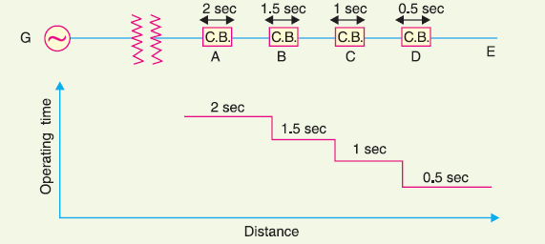

Fig.1

**(*i*)** *Using definite time relays.* Fig.1 shows the overcurrent protection of a radial feeder by definite time relays. The time of operation of each relay is fixed and is independent of the operating current. Thus relay *D* has an operating time of 0·5 second while for other relays, time delay* is successively increased by 0·5 second. If a fault occurs in the section *DE*, it will be cleared in 0·5 second by the relay and circuit breaker at *D* because all other relays have higher operating time. In this way only section *DE* of the system will be isolated. If the relay at *D* fails to trip, the relay at *C* will operate after a time delay of 0·5 second *i.e.* after 1 second from the occurrence of fault. The disadvantage of this system is that if there are a number of feeders in series, the tripping time for faults near the supply end becomes high (2 seconds in this case). However, in most cases, it is necessary to limit the maximum tripping time to 2 seconds. This disadvantage can be overcome to a reasonable extent by using inverse-time relays.

**(*ii*)** *Using inverse time relays.* Fig. 2. shows overcurrent protection of a radial feeder using

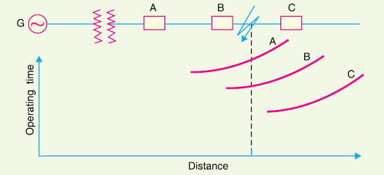

Fig.2

inverse time relays in which operating time is inversely proportional to the operating current. With this arrangement, the farther the circuit breaker from the generating station, the shorter is its relay operating time. The three relays at *A*, *B* and *C* are assumed to have inverse-time characteristics. A fault in section *BC* will give relay times which will allow breaker at *B* to trip out before the breaker at *A*.

**5.1.2. Parallel feeders.** Where continuity of supply is particularly necessary, two parallel feeders may be installed. If a fault occurs on one feeder, it can be disconnected from the system and continuity of supply can be maintained from the other feeder. The parallel feeders cannot* be protected by non-directional overcurrent relays only. It is necessary to use directional relays also and to grade the time setting of relays for selective trippings.

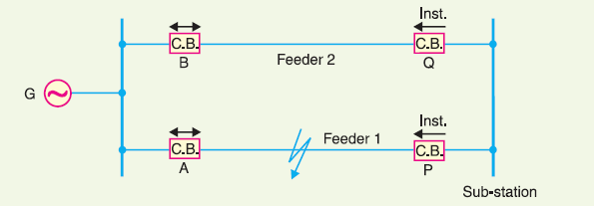

Fig.3

Fig. 3 shows the system where two feeders are connected in parallel between the generating station and the sub-station. The protection of this system requires that

**(*i*)** each feeder has a non-directional overcurrent relay at the generator end. These relays should have inverse-time characteristic.

**(*ii*)** each feeder has a reverse power or directional relay at the sub-station end. These relays should be instantaneous type and operate only when power flows in the reverse direction *i.e*. in the direction of arrow at *P* and *Q*. Suppose an earth fault occurs on feeder 1 as shown in Fig. 23.6. It is desired that only circuit breakers at *A* and *P* should open to clear the fault whereas feeder 2 should remain intact to maintain the continuity of supply. In fact, the above arrangement accomplishes this job. The shown fault is fed *via* two routes*, viz*.

**(*a*)** directly from feeder 1 *via* the relay *A*

**(*b*)** from feeder 2 *via B*, *Q,* sub-station and *P*

Therefore, power flow in relay *Q* will be in normal direction but is reversed in the relay *P*. This causes the opening of circuit breaker at *P*. Also the relay *A* will operate while relay *B* remains inop-erative. It is because these relays have inverse-time characteristics and current flowing in relay *A* is in excess of that flowing in relay *B*. In this way only the faulty feeder is isolated.

**5.1.3. Ring main system.** In this system, various power stations or sub-stations are interconnected by alternate routes, thus forming a closed ring. In case of damage to any section of the ring, that section may be disconnected for repairs, and power will be supplied from both ends of the ring, thereby maintaining continuity of supply.

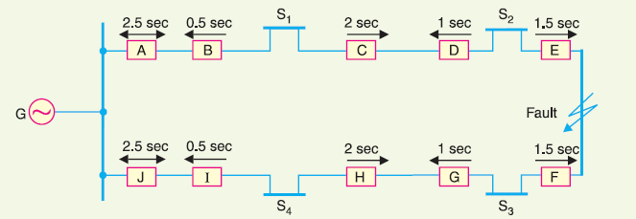

Fig.4

Fig. 4 shows the single line diagram of a typical ring main system consisting of one generator *G* supplying four sub-stations *S*1, *S*2, *S*3 and *S*4. In this arrangement, power can flow in both directions under fault conditions. Therefore, it is necessary to grade in both directions round the ring and also to use directional relays. In order that only faulty section of the ring is isolated under fault conditions, the types of relays and their time settings should be as follows :

**(*i*)** The two lines leaving the generating station should be equipped with non-directional overcurrent relays (relays at *A* and *J* in this case).

**(*ii*)** At each sub-station, reverse power or directional relays should be placed in both incoming and outgoing lines (relays at *B*, *C*, *D*, *E*, *F*, *G*, *H* and *I* in this case).

**(*iii*)** There should be proper relative time-setting of the relays. As an example, going round the loop *G S*1 *S*2 *S*3 *S*4 *G* ; the outgoing relays (*viz* at *A*, *C*, *E*, *G* and *I*) are set with decreasing time limits *e.g*.

*A* = 2·5 sec, *C* = 2 sec, *E* = 1·5 sec *G* = 1 sec and *I* = 0·5 sec

Similarly, going round the loop in the opposite direction (*i.e*. along *G S*4 *S*3 *S*2 *S*1 *G*), the *outgoing relays* (*J*, *H*, *F*, *D* and *B*) are also set with a decreasing time limit *e.g*.

*J* = 2·5 sec, *H* = 2 sec, *F* = 1·5 sec, *D* = 1 sec, *B* = 0·5 sec.

Suppose a short circuit occurs at the point as shown in Fig. 23.7. In order to ensure selectivity, it is desired that only circuit breakers at *E* and *F* should open to clear the fault whereas other sections of the ring should be intact to maintain continuity of supply. In fact, the above arrangement accomplishes this job. The power will be fed to the fault *via* two routes *viz* (*i*) from *G* around *S*1 and *S*2 and (*ii*) from *G* around *S*4 and *S*3. It is clear that relays at *A*, *B*, *C* and *D* as well as *J*, *I*, *H* and *G* will not trip. Therefore, only relays at *E* and *F* will operate before any other relay operates because of their lower time-setting.

5.2. Differential Pilot-Wire Protection

The differential pilot-wire protection is based on the principle that under normal conditions, the current entering one end of a line is equal to that leaving the other end. As soon as a fault occurs between the two ends, this condition no longer holds and the difference of incoming and outgoing currents is arranged to flow through a relay which operates the circuit breaker to isolate the faulty line. There are several differential protection schemes in use for the lines. However, only the following two schemes will be discussed :

**1.** Merz-Price voltage balance system

**2.** Translay scheme

**1. Merz-Price voltage balance system.** Fig. 5 shows the single line diagram of Merz-Price voltage balance system for the protection of a 3-phase line. Identical current transformers are placed in each phase at both ends of the line. The pair of *CTs* in each line is connected in series with a relay in such a way that under normal conditions, their secondary voltages are equal and in opposition *i.e.* they balance each other.

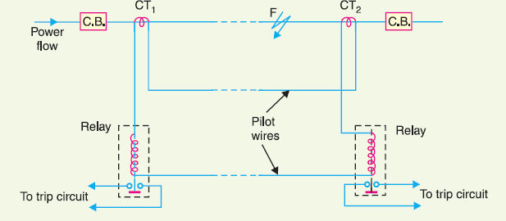

Fig.5

Under healthy conditions, current entering the line at one-end is equal to that leaving it at the other end. Therefore, equal and opposite voltages are induced in the secondaries of the *CT*s at the two ends of the line. The result is that no current flows through the relays. Suppose a fault occurs at point *F* on the line as shown in Fig. 5. This will cause a greater current to flow through *CT*1 than through *CT*2. Consequently, their secondary voltages become unequal and circulating current flows through the pilot wires and relays. The circuit breakers at both ends of the line will trip out and the faulty line will be isolated.

Fig. 6 shows the connections of Merz-Price voltage balance scheme for all the three phases of the line.

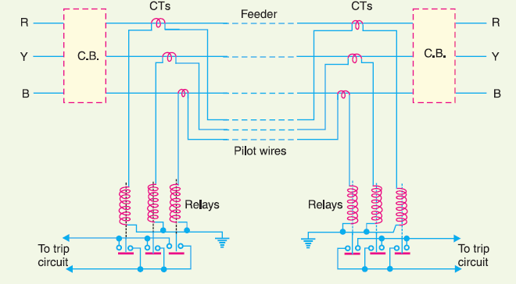

Fig.6

**Advantages**

**(*i*)** This system can be used for ring mains as well as parallel feeders.

**(*ii*)** This system provides instantaneous protection for ground faults. This decreases the possibility of these faults involving other phases.

**(*iii*)** This system provides instantaneous relaying which reduces the amount of damage to overhead conductors resulting from arcing faults.

**Disadvantages**

**(*i*)** Accurate matching of current transformers is very essential.

**(*ii*)** If there is a break in the pilot-wire circuit, the system will not operate.

**(*iii*)** This system is very expensive owing to the greater length of pilot wires required.

**(*iv*)** In case of long lines, charging current due to pilot-wire capacitance* effects may be sufficient to cause relay operation even under normal conditions.

**(*v*)** This system cannot be used for line voltages beyond 33 kV because of constructional difficulties in matching the current transformers.

**2. Translay scheme.** This system is similar to voltage balance system except that here balance or opposition is between the voltages induced in the secondary windings wound on the relay magnets and *not* between the secondary voltages of the line current transformers. This permits to use current transformers of normal design and eliminates one of the most serious limitations of original voltage balance system, namely ; its limitation to the system operating at voltages not exceeding 33 kV.

**Constructional details.** Fig. 7 shows the simplified diagram illustrating the principle of *Translay scheme. It consists of two identical double winding induction type relays fitted at either end of the feeder to be protected. The primary circuits (11, 11*a*) of these relays are supplied through a pair of current transformers. The secondary windings (12, 13 and 12*a*, 13*a*) of the two relays are connected in series by pilot wires in such a way that voltages induced in the former opposes the other. The compensating devices (18, 18*a*) neutralise the effects of pilot-wire capacitance currents and of inherent lack of balance between the two current transformers.

**Operation.** Under healthy conditions, current at the two ends of the protected feeder is the same and the primary windings (11, 11*a*) of the relays carry the same current. The windings 11 and 11*a* induce equal e.m.f.s in the secondary windings 12, 12*a* and 13, 13*a*. As these windings are so connected that their induced voltages are in opposition, no current will flow through the pilots or operating coils and hence no torque will be exerted on the disc of either relay. In the event of fault on the protected feeder, current leaving the feeder will differ from the current entering the feeder. Consequently, unequal voltages will be induced in the secondary windings of the relays and current will circulate between the two windings, causing the torque to be exerted on the disc of each relay. As the

direction of secondary current will be opposite in the two relays, therefore, the torque in one relay will tend to close the trip circuit while in the other relay, the torque will hold the movement in the normal unoperated position. It may be noted that resulting operating torque depends upon the position and nature of the fault in the protected zone and atleast one element of either relay will operate under any fault condition.

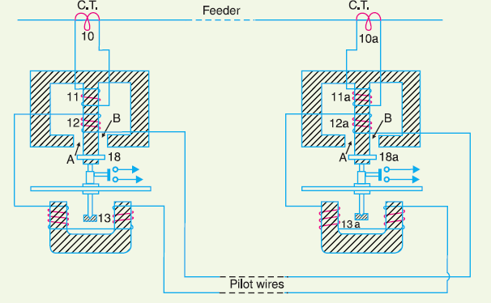

Fig.7

It is worthwhile here to mention the role of closed copper rings (18, 18*a*) in neutralising the effects of pilot capacitive currents. Capacitive currents lead the voltage impressed across the pilots by 90º and when they flow in the operating winding 13 and 13*a* (which are of low inductance), they produce fluxes that also lead the pilot voltage by 90º. Since pilot voltage is that induced in the secondary windings 12 and 12*a*, it lags by a substantial angle behind the fluxes in the field magnet air gaps *A* and *B*. The closed copper rings (18, 18*a*) are so adjusted that this angle is approximately 90º. In this way fluxes acting on the disc are in phase and hence no torque is exerted on the relay disc.

**Advantages**

**(*i*)** The system is economical as only two pilot wires are required for the protection of a 3-phase line.

**(*ii*)** Current transformers of normal design can be used.

**(*iii*)** The pilot wire capacitance currents do not affect the operation of relays.

5.3. Distance Protection

Both time-graded and pilot-wire system are not suitable for the protection of very long high voltage transmission lines. The former gives an unduly long time delay in fault clearance at the generating station end when there are more than four or five sections and the pilot-wire system becomes too expensive owing to the greater length of pilot wires required. This has led to the development of distance protection in which the action of relay depends upon the distance (or impedance) between the point where the relay is installed and the point of fault. This system provides discrimination protection without employing pilot wires. The principle and operation of distance relays have already

been discussed in earlier topics. We shall now consider its application for the protection of transmission lines. Fig. 8 shows a simple system consisting of lines in series such that power can flow only from left to right. The relays at *A*, *B* and *C* are set to operate for impedance less than *Z*1, *Z*2 and *Z*3 respectively. Suppose a fault occurs between sub-stations *B* and *C*, the fault impedance at power station and sub-station *A* and *B* will be *Z*1 + *Z* and *Z* respectively. It is clear that for the portion shown, only relay at *B* will operate. Similarly, if a fault occurs within section *AB*, then only relay at *A* will operate. In this manner, instantaneous protection can be obtained for all conditions of operation.

In actual practice, it is not possible to obtain instantaneous protection for complete length of the line due to inaccuracies in the relay elements and instrument transformers. Thus the relay at *A* [See

Fig. 8 would not be very reliable in distinguishing between a fault at 99% of the distance *AB* and the one at 101% of distance *AB*. This difficulty is overcome by using *‘three-zone’* distance protection shown in Fig. 9.

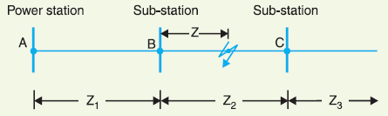

Fig.8

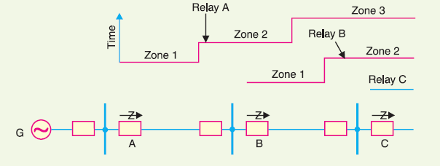

Fig.9

In this scheme of protection, three distance elements are used at each terminal. The zone 1 element covers first 90% of the line and is arranged to trip instantaneously for faults in this portion. The zone 2 element trips for faults in the remaining 10% of the line and for faults in the next line section, but a time delay is introduced to prevent the line from being tripped if the fault is in the next section. The zone 3 element provides back-up protection in the event a fault in the next section is not cleared by its breaker.

5.4.Transformer Protection

Transformers are static devices, totally enclosed and generally oil immersed. Therefore, chances of faults occurring on them are very rare. However, the consequences of even a rare fault may be very serious unless the transformer is quickly disconnected from the system. This necessitates to provide adequate automatic protection for transformers against possible faults. Small distribution transformers are usually connected to the supply system through series fuses instead of circuit breakers. Consequently, no automatic protective relay equipment is required. However, the probability of faults on power transformers is undoubtedly more and hence automatic protection is absolutely necessary.

**Common transformer faults.** As compared with generators, in which many abnormal conditions may arise, power transformers may suffer only from :

**(*i*)** open circuits

**(*ii*)** overheating

**(*iii*)** winding short-circuits *e.g.* earth-faults, phase-to-phase faults and inter-turn faults.

An open circuit in one phase of a 3-phase transformer may cause undesirable heating. In practice, relay protection is not provided against open circuits because this condition is relatively harmless. On the occurrence of such a fault, the transformer can be disconnected manually from the system. Overheating of the transformer is usually caused by sustained overloads or short-circuits and very occasionally by the failure of the cooling system. The relay protection is also not provided against this contingency and thermal accessories are generally used to sound an alarm or control the banks of fans. Winding short-circuits (also called *internal faults*) on the transformer arise from deterioration of winding insulation due to overheating or mechanical injury. When an internal fault occurs, the transformer must be disconnected quickly from the system because a prolonged arc in the transformer may cause oil fire. Therefore, relay protection is absolutely necessary for internal faults.

5.5. Protection Systems for Transformers

For protection of generators, Merz-Price circulating-current system is unquestionably the most satisfactory. Though this is largely true of transformer protection, there are cases where circulating current system offers no particular advantage over other systems or impracticable on account of thetroublesome conditions imposed by the wide variety of voltages, currents and earthing conditions invariably associated with power transformers. Under such circumstances, alternative protective systems are used which in many cases are as effective as the circulating-current system. The principal relays and systems used for transformer protection are :

**(*i*)** *Buchholz devices* providing protection against all kinds of incipient faults *i.e*. slow-developing faults such as insulation failure of windings, core heating, fall of oil level due to leaky joints etc.

**(*ii*)** *Earth-fault relays* providing protection against earth-faults only.

**(*iii*)** *Overcurrent relays* providing protection mainly against phase-to-phase faults and overloading.

**(*iv*)** *Differential system* (or circulating-current system) providing protection against both earth and phase faults.

The complete protection of transformer usually requires the combination of these systems. Choice of a particular combination of systems may depend upon several factors such as **(*a*)** size of the transformer **(*b*)** type of cooling **(*c*)** location of transformer in the network **(*d*)** nature of load supplied and **(*e*)** importance of service for which transformer is required. In the following sections, above systems of protection will be discussed in detail.

5.6. Buchholz Relay

Buchholz relay is a gas-actuated relay installed in oil immersed transformers for protection against all kinds of faults. Named after its inventor, Buchholz, it is used to give an alarm in case of incipient (*i.e.* slow-developing) faults in the transformer and to disconnect the transformer from the supply in the event of severe internal faults. It is usually installed in the pipe connecting the conservator to the main tank as shown in Fig. 10. It is a universal practice to use Buchholz relays on all such oil immersed transformers having ratings in *excess of 750 kVA.

**Construction.** Fig. 11 shows the constructional details of a Buchholz relay. It takes the form of a domed vessel placed in the connecting pipe between the main tank and the conservator. The device has two elements. The upper element consists of a mercury type switch attached to a float. The lower element contains a mercury switch mounted on a hinged type flap located in the direct path of the flow of oil from the transformer to the conservator. The upper element closes an alarm circuit during incipient faults whereas the lower element is arranged to trip the circuit breaker in case of severe internal faults.

**Operation.** The operation of Buchholz relay is as follows :

**(*i*)** In case of incipient faults within the transformer, the heat due to fault causes the decomposition of some transformer oil in the main tank. The products of decomposition contain more than 70% of hydrogen gas. The hydrogen gas being light tries to go into the conservator

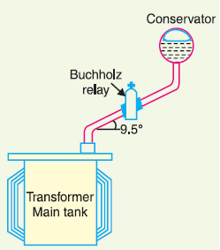

Fig.10

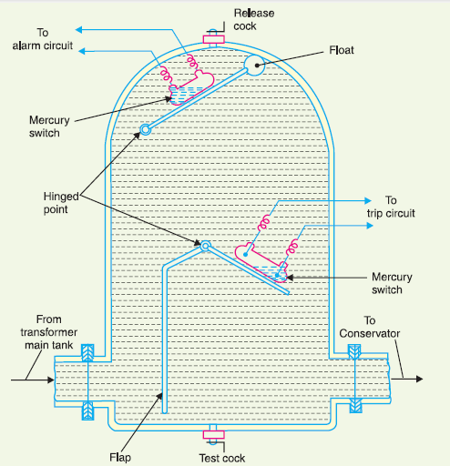

Fig.11

tor and in the process gets entrapped in the upper part of relay chamber. When a predetermined amount of gas gets accumulated, it exerts sufficient pressure on the float to cause it to tilt and close the contacts of mercury switch attached to it. This completes the alarm circuit to sound an *alarm.

**(*ii*)** If a serious fault occurs in the transformer, an enormous amount of gas is generated in the main tank. The oil in the main tank rushes towards the conservator *via* the Buchholz relay and in doing so tilts the flap to close the contacts of mercury switch. This completes the trip circuit to open the circuit breaker controlling the transformer.

***Advantages***

**(*i*)** It is the simplest form of transformer protection.

**(*ii*)** It detects the incipient faults at a stage much earlier than is possible with other forms of protection.

***Disadvantages***

**(*i*)** It can only be used with oil immersed transformers equipped with conservator tanks.

**(*ii*)** The device can detect only faults below oil level in the transformer. Therefore, separate protection is needed for connecting cables.

5.7. Earth-Fault or Leakage Protection

An earth-fault usually involves a partial breakdown of winding insulation to earth. The resulting leakage current is considerably less than the short-circuit current. The earth-fault may continue for a long time and cause considerable damage before it ultimately develops into a short-circuit and removed from the system. Under these circumstances, it is profitable to employ earth-fault relays in order to ensure the disconnection of earth-fault or leak in the early stage. An earth-fault relay is essentially an overcurrent relay of low setting and operates as soon as an earth-fault or leak develops. One method of protection against earth-faults in a transformer is the \**core-balance leakage protection* shown in Fig. 12.

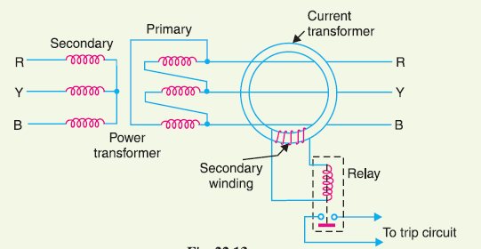

Fig.12

The three leads of the primary winding of power transformer are taken through the core of a current transformer which carries a single secondary winding. The operating coil of a relay is connected to this secondary. Under normal conditions (*i.e.* no fault to earth), the vector sum of the three phase currents is zero and there is no resultant flux in the core of current transformer no matter how much the load is out of balance. Consequently, no current flows through the relay and it remains inoperative. However, on the occurrence of an earth-fault, the vector sum of three phase currents is no longer zero. The resultant current sets up flux in the core of the C.T. which induces e.m.f. in the secondary winding. This energises the relay to trip the circuit breaker and disconnect the faulty transformer from the system.

5.8. Combined Leakage and Overload Protection

The core-balance protection described above suffers from the drawback that it cannot provide protection against overloads. If a fault or leakage occurs between phases, the core-balance relay will not operate. It is a usual practice to provide combined leakage and overload protection for transformers. The earth relay has low current setting and operates under earth or leakage faults only. The overload relays have high current setting and are arranged to operate against faults between the phases. Fig. 13 shows the schematic arrangement of combined leakage and overload protection. In this system of protection, two overload relays and one leakage or earth relay are connected as shown. The two overload relays are sufficient to protect against phase-to-phase faults. The trip contacts of overload relays and earthfault relay are connected in parallel. Therefore, with the energising of either overload relay or earth relay, the circuit breaker will be tripped.

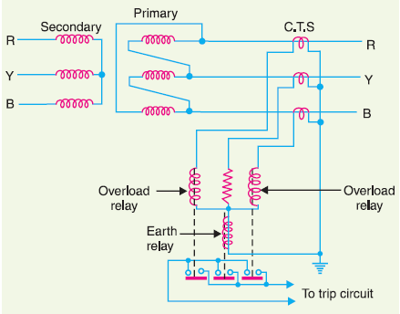

Fig.13

5.9. Applying Circulatingcurrent System to Transformers

Merz-Price circulating -current principle is commonly used for the protection of power transformers against earth and phase faults. The system as applied to transformers is fundamentally the same as that for generators but with certain complicating features not encountered in the generator application. The complicating features and their remedial measures are briefed below :

**(*i*)** In a power transformer, currents in the primary and secondary are to be compared. As these two currents are usually different, therefore, the use of identical transformers (of same turn ratio) will give differential current and operate the relay even under no load conditions. The difference in the magnitude of currents in the primary and secondary of power transformer is compensated by different turn ratios of CTs. If T is the turn-ratio of power transformer, then turnratio of CTs on the *l.v.* side is made T times that of the CTs on the *h.v.* side. Fulfilled this condition, the secondaries of the two CTs will carry identical currents under normal load conditions. Consequently,

no differential current will flow through the relay and it remains inoperative.

**(*ii*)** There is usually a phase difference between the primary and secondary currents of a 3-phase power transformer. Even if CTs of the proper turn-ratio are used, a differential current may flow through the relay under normal conditions and cause relay operation. The correction for phase difference is effected by appropriate connections of CTs. The CTs on one side of the power transformer are connected in such a way that the resultant currents fed into the pilot wires are displaced in phase from the individual phase currents in the same direction as, and by an angle equal to, the phase shift between the power-transformers primary and secondary currents. The table 1 below shows the type of connections to be employed for CTs in order to compensate for the phase difference in the primary and secondary currents of power transformer.

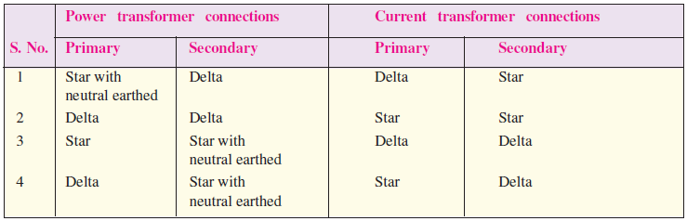

Table.1

Thus referring to the above table, for a delta/star power transformer, the CTs on the delta side must be connected in star and those on the star side in delta.

**(*iii*)** Most transformers have means for tap changing which makes this problem even more difficult. Tap changing will cause differential current to flow through the relay even under normal operating conditions. The above difficulty is overcome by adjusting the turn-ratio of CTs on the side of the power transformer provided with taps.

**(*iv*)** Another complicating factor in transformer protection is the magnetising in-rush current. Under normal load conditions, the magnetising current is very small. However, when a transformer is energised after it has been taken out of service, the magnetising or in-rush current can be extremely high for a short period. Since magnetising current represents a current going into the transformer without a corresponding current leaving, it appears as a fault current to differential relay and may cause relay operation.

In order to overcome above difficulty, differential relays are set to operate at a relatively high degree of unbalance. This method decreases the sensitivity of the relays. In practice, advantage is taken of the fact that the initial in-rush currents contain prominent second-harmonic component. Hence, it is possible to design a scheme employing second-harmonic bias features, which, being tuned to second-harmonic frequency only, exercise restrain during energising to prevent maloperation. While applying circulating current principle for protection of transformers, above precautions are necessary in order to avoid inadvertent relay operation.

5.10. Circulating-Current Scheme for Transformer Protection

Fig. 14 shows Merz-Price circulating-current scheme for the protection of a 3-phase delta/delta power transformer against phase-toground and phase-to-phase faults. Note that *CT*s on the two sides of the transformer are connected in star. This compensates for the phase difference between the power transformer primary and secondary. The *CT*s on the two sides are connected by pilot wires and one relay is used for each pair of *CT*s. During normal operating conditions, the secondaries of *CT*s carry identical currents. Therefore, the currents entering and leaving the pilot wires at both ends are the same and no current flows through the relays. If a ground or phase-to-phase fault occurs, the currents in the secondaries of *CT*s will no longer be the same and the differential current flowing through the relay circuit will clear the breaker on both sides of the transformer. The-protected zone is limited to the region between *CT*s on the high-voltage side and the *CT*s on the low-voltage side of the power transformer. It is worthwhile to note that this scheme also provides protection for short-circuits between turns on the same phase winding. When a short-circuit occurs between the turns, the turn-ratio of the power transformer is altered and causes unbalance between current transformer pairs. If turn-ratio of power transformer is altered sufficiently, enough differential current may flow through the relay to cause its operation. However, such short-circuits are better taken care of by Buchholz relays.

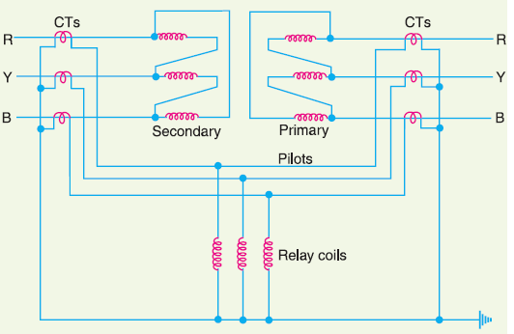

Fig.14